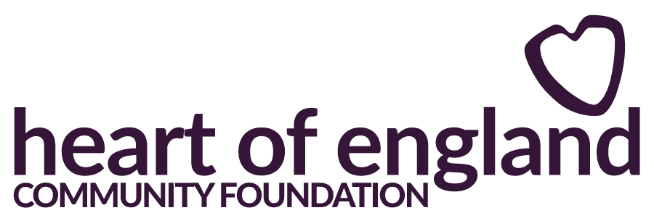

Social Fabric Fund Expression of Interest Questions

- Please outline the aims and objectives of your organisation
- Does your organisation have its own address that is separate to the home address of any individual associated with the organisation?
- Are you part of a larger regional or national organisation?
- What is the name of the national organisation?
- Is your organisation new and has not yet produced a set of annual accounts?
- What was your organisation's income over the last complete accounting year?
- What end date do the accounts relate to?
- Expenditure over last complete accounting year?
- What were your unrestricted reserves at the end of your last complete accounting year?
- Please explain your reserves
- Please provide a 12 month income & expenditure forecast
- How did you hear about Heart of England Community Foundation?
- How many of each of the following are involved in the organisation?
- Full time paid staff / workers
- Part time paid staff / workers
- Volunteers
- Management Committee or Trustees
- Project, Activity or Service name
- Requested funding start date
- Requested funding end date
- Approximately How many months do you anticipate the duration of this project.
- Which of the Social Fabric Fund principles does the proposal meet and why? (250 words)
- Approximately How many months do you anticipate the duration of this project.
- How many volunteer hours will contribute to this specific project, activity or service?
- Apart from the community, who will be responsible for delivering the proposal? What is their background, skills and experience? (250 words)
- How will you measure the impact of your project, activity or service and how will you report the difference the funding has made? (250 words)
- Is part of the proposal a community asset transfer?
- If yes, relating to what building or piece of land?
- How many people will benefit from this funding?
- How will the community benefit from the proposal? (250 words)
- Which Local Authority area do the people who will benefit from the proposed activity, live in?
- How has the community been involved identifying local priorities and helping shape the proposal? (250 words)
- How will the community continue to be involved with shaping and delivering the proposal. (250 words)
- What are the arrangements for longer-term sustainability beyond the term of any funding award? (250 words)
- How does the proposal align to the following community power fundamentals? (250 words)
- Involve communities in decision making:
- Work alongside communities to take practical action.
- Enable communities to lead.
- Does the fund cover Revenue, Capital or Both?
- What are your outline costs?
- Are there any staff costs?
- Please give details showing how you have calculated staff costs.
- Requested amount Total cost
- Are there any volunteer costs?
- Number of volunteers and breakdown of 'out-of-pocket' volunteer expenses
- Requested amount Total cost
- Are there any operational/activity costs?
- Itemise individual cost elements to the delivery of the project, activity or service.
- Requested amount Total cost
- Are there any publicity costs?
- Clarify what these costs will fund.
- Requested amount Total cost
- Are there any office, overhead, premises costs?
- Costs related to the delivery of this project/activity only - you may wish to highlight this as a percentage or as apportioned costs
- Requested amount Total cost
- Are there any capital costs?
- Cost per item & how many items
- Requested amount Total cost
- Please provide three quotes for each capital item that costs more than £300
- Do you have any other costs that you wish to add?
- Cost per item
- Requested amount Total cost
- How much are you applying for (including VAT)?
- What is the total cost of the project, activity or service?
- Is there a remaining balance?
- Please provide details on how the remaining balance will be covered and whether it has already been secured.

