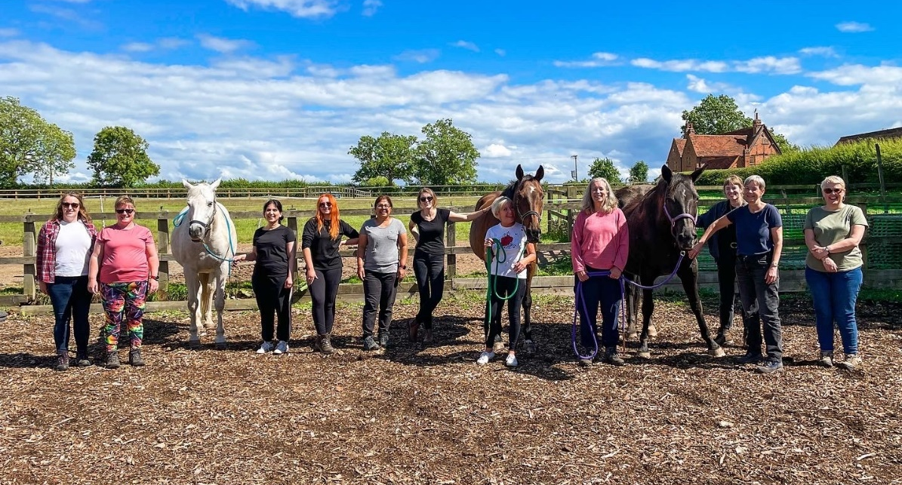
Case study template
[Insert title here]
Name of your Organisation
OR
A snippet of an impactful quote that was used in the case study e.g. It was a lifeline
[Insert image here]
A landscape image of high quality that links to the case study, preferably including people but ensure they have consented to their photo being public.
First paragraph
In a few lines briefly summarise the grant you were awarded (who, why, where, when, what)
[Your organisations name], a community group that deliver XYZ, were awarded £XXXX through the Heart of England Community Foundation to support XYZ.
Second paragraph
This is where the main body of the text begins. Explain in further detail about your organisation and why the grant was needed. Support this with a quote from a project lead.
[“Insert quote from project lead.”]
The rest of the text
Continue explaining the impact of the grant and how it’s supported your work. Back this up with some statistics and/or an impactful quote(s) from a beneficiary(s).
[Insert quote from beneficiary e.g. “This service was a lifeline to me because of XYZ.”]
Final paragraph
Conclude case study either with a paragraph OR “quote” summarising the impact and feel free to thank the funder for the grant or explain why funders are needed to support organisations like yours.
[Insert your organisation’s logo here]

